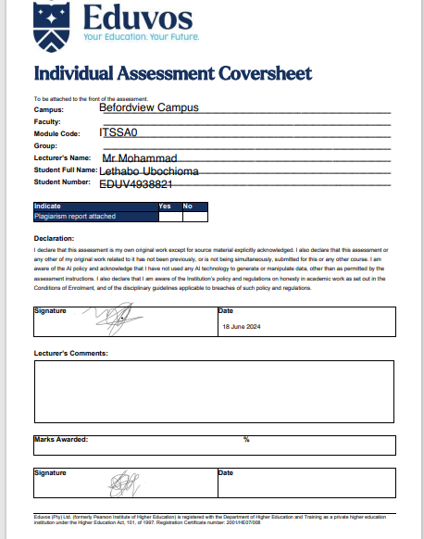
INDEX :
PRJOECT SPECIFICATIONS:
Create an ER Diagram for the scenario above.
Create a database.
Create the tables for the scenario above.
Insert sample data into the tables you created above.
Create the following views:
• vw_Flight – All flights appearing on the website, their availability and prices per reservation.
• vw_AffordableFlight – Select the top three flights with unchanged reservation and booking price.
• vw_SeniorUsers - Select all senior users who qualify for a discount based on their age.
• vw_OnboardCustomers – Select all member names as well as the total number of classes that each member will attend. HINT: Use the COUNT function. Create the following stored procedures:
• sp_AddNewFlights – Insert new flights as they become available.
• sp_UpdateFlyingTimes – Update the flying times as requested by customers based on demand.
• sp_DeleteTicket – Delete a ticket record. A ticket may only be deleted when it has been used or its date has expired.
• sp_Report – Print the details of a specified flight class and each member’s name and contact number assigned to the class.
Create 2 (two) after triggers on the tables you have created.
Create Indexes on the tables you created.
Create a zipped backup of your database and hand it in with your script files.

ER DIAGRAM:

